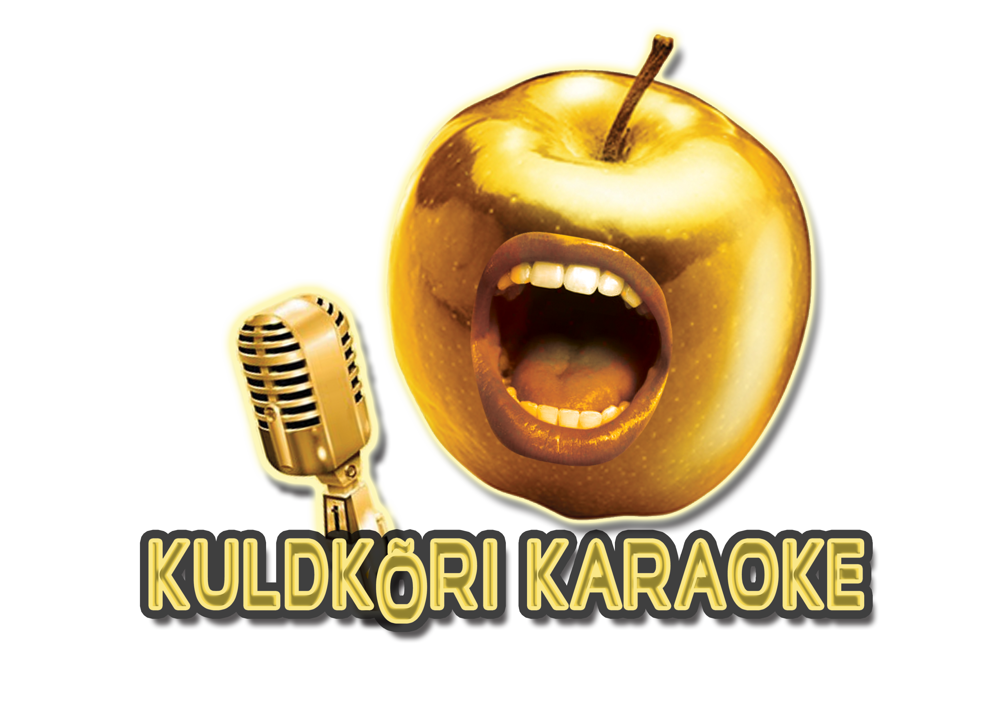

UUED INGLISEKEELSED KARAOKE LAULUD 15.03.2022

VAB001-01 Olivia Rodrigo - Drivers License
VAB001-02 Lewis Capaldi - Don t Get Me Wrongound
VAB001-03 Aretha Franklin - (You Make Me Feel Like) A Natural Woman
VAB001-04 Rag'n'Bone Man - Human
VAB001-05 Aladdin - A Whole New World ( 1992 Disney film-Duett )
VAB001-06 Adele - Easy On Me
COR003-19 Frank Sinatra - Girl from Ipanema
COR003-18 Sam Smith feat. Disclosure - Latch
COR003-17 Sam Smith - In The Lonely Hour (Acoustic)
COR003-16 Miley Cyrus - When I Look At You
COR003-15 Deana Carter - Strawberry Wine
COR003-14 Morgan Wallen - Whiskey Glasses
COR003-13 Alison Krauss & Union Station - When You Say Nothing At All
COR003-12 Sarah McLachlan - Angel
COR003-11 Chris Rea - Road To Hell
COR003-10 Chris Rea - Josephine
COR003-09 Duffy - Mercy
COR003-08 Ed Sheeran - Bad Habits
COR003-07 Weeknd - Save Your Tears
COR003-06 Frank Sinatra - Fly Me to the Moon
COR003-05 Bruno Mars - Talking to the Moon
COR003-04 Faith No More - From Out of Nowhere
COR003-03 Willie Nelson - On the Road Again
COR003-02 Ed Sheeran - Shivers
COR003-01 Amy Winehouse - Valerie
COR002-20 Camila Cabello - Don`t Go Yet
COR002-19 Aurora feat. Idina Menzel - Into the Unknown (Cast of Frozen 2)
COR002-18 Elton John feat. Dua Lipa - Cold Heart (PNAU remix)
COR002-17 Sister Sledge - We Are Family
COR002-16 Nathan Evans - Wellerman
COR002-15 Josh Turner - Your Man
COR002-14 Justin Wellington feat. Small Jam - Iko Iko
COR002-13 Blake Shelton - God`s Country
COR002-12 Green Day - Boulevard Of Broken Dreams
COR002-11 Bruno Mars - Count On Me
COR002-10 Pink Floyd - Wish You Were Here
COR002-09 George Michael - Faith
COR002-08 Mary J Blige - Not Gon Cry
COR002-07 Walk the Moon- Shut Up and Dance
COR002-06 Cast of Frozen - For The First Time In Forever (Duet)
COR002-05 Cast of Frozen - Love Is An Open Door (Duet)
COR002-04 Cast of Tangled - When Will My Life Begin
COR002-03 Amy Winehouse - Back To Black
COR002-02 Cast of Moana - How Far Il`l Go
COR002-01 Bruno Mars - Marry You
COR001-20 Cast of Frozen 2 - AllIs Found
COR001-19 Harry Styles - Watermelon Sugar
COR001-18 Disney Original - Colors Of The Wind
COR001-17 Cast of The Lion King - Hakuna Matata
COR001-16 Marshmello feat. Bastille - Happier
COR001-15 Cast of Beauty and the Beast - Beauty And The Beast
COR001-14 Disney Original - Under The Sea
COR001-13 Weeknd - In Your Eyes
COR001-11 Elton John - Rocket Man
COR001-10 Elvis Presley - Love Me Tender
COR001-09 Elvis Presley - In The Ghetto
COR001-08 REM - Man On The Moon
COR001-07 Mäneskin - Beggin
COR001-06 Walker Hayes - Fancy Like
COR001-05 Bruno Mars - Lazy Song
COR001-04 Taylor Swift - Love Story
COR001-03 Celine Dion - It's All Coming Back To Me Now
COR001-02 Adele - When We Were Young
COR001-01 Rihanna - Take a Bow

Facebook: Kuldkõri karaoke
Tellimine: 56508056, marko@peoelu24.ee

